May 1984 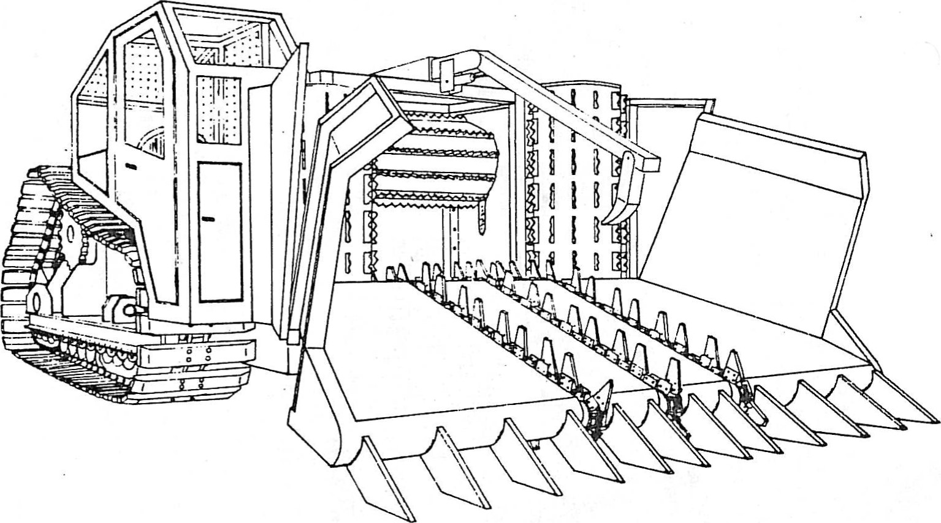

**Durham-Based Company Offers One Answer to Brush Utilization Puzzle**

The American farmer is best known for his inventiveness. a fact that has spurred world-wide recognition of U.S. agriculture as the most productive food machine in the world. High energy costs caused growers and some agriculture-related businesses to take a careful look at what used to be considered trash - almond brush.

Durham-based Tink Inc. is one among several other companies that joined in an effort to research and develop a machine that could systematically collect brush from an orchard. turn it into a fuel source. and sell it as a reuseable by-product. Those who are familiar with the company know it best for its origination of skid steer

|  |  |
| --- | --- |
| loader attachments and subsequent development or the roll-out bucket. a concept that adds dump height and reach to loaders.  Out of the development of these concepts. Tink built a world-wide marketing network for hydraulic trenchers and roll-out buckets. Recognizing a need for development of equipment that could convert almond brush as a reuseable resource. Tink President Bob DuBose invented the Wood Fuel Harvester. while his brother. Tink Inc. Vice President Dan DuBose. was charged with production.  There are three separate companies that are charged with various aspects | of this concept: Tink Inc. the manufacturer and developer: Wood Fuel Harvesting. owner and responsible for marketing or the wood chips: and Chipco Company. which operates the machine. does the trucking and contracts acreage for pick- up services. Chico is owned by Exchange grower Dean Grissom who also docs custom harvesting. The machine itself costs $525,000 to manufacture. excluding the research and development involved.  Plans are already brewing to develop a complete bankout system adaptable to picking up the shredded almond brush. |